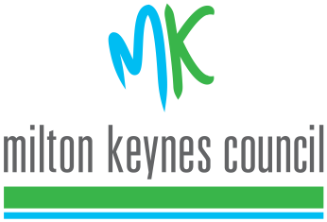
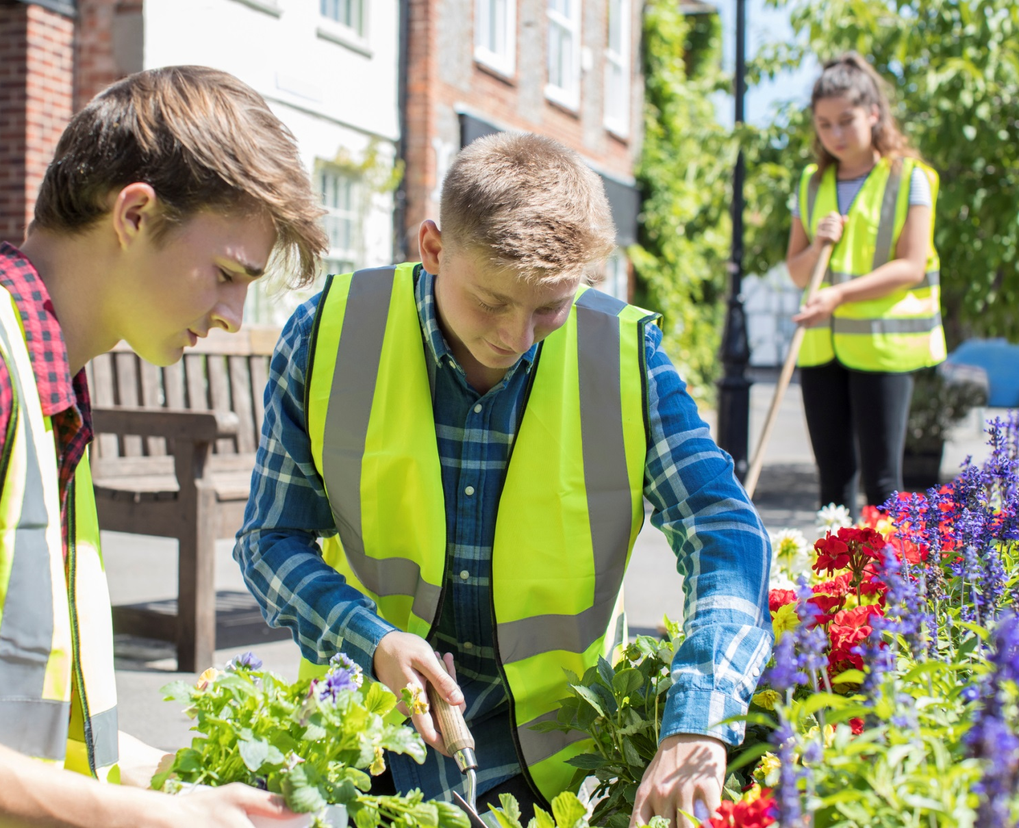

Celebrating Youth People’s involvement in Citizenship and Democracy

The Mayor’s Award is your opportunity to show the work which encourages others to get involved and make a difference in the community.
We know that there’s some amazing things going on and we would like to hear about it.
Any questions:
Email mkyf@milton-keynes.gov.uk
Call, text or Whatsapp 07984157122
Deadline for the competition is midday on the 27th April 2020
MK Mayor’s Award

Welcome to the MK Mayor’s Award!

Thank you for applying for the Mayor’s Award. This is the first year that MK Council have run this opportunity for young people to be recognised for their work in supporting democracy and citizenship, in this way.

There are some rules to be aware of and to follow:

- Applications can be from any primary or secondary educational establishment in Milton Keynes. Those applying should be within the age group of that establishment (from 5 but not over the age of 19 unless in a special school). Applications can be typed.
- Parents/carers are not able to enter their children.
- Applications must show how democracy or citizenship was relevant to the work. It could have been part of a bigger project/task/event/activity (e.g. a questionnaire that sparked the idea of a disco) or a talk and a vote on what should happen at the youth club.
- Those nominated could be a group or an individual.
- A good application will also show how the activity was delivered and what outcomes it had for the people involved. So please try to include all of the important elements.
- Nominators can put in more than one application for the period from 1st April 2019 to 30th March 2020.
- Applications will be judged against each other but the Mayor of Milton Keynes.
Time scales, Deadlines and Judging
31st March 2020 Open nominations
27th April Deadline for nominations
Late April Judging by Mayor of Milton Keynes
Mid May Winner will be notified (via the nominee) and announced on social media. Trophies will be presented once it is safe to do so.

Please be aware that all applications will be shared with the Mayor of MK.

To enter applications must be:
- For a young person who lives in Milton Keynes and aged between 5-18 or older if attending a special school.
- Fully completed
- Completed by someone who is contactable and happy to pass on information to young people.

Completed forms can be returned to Roz Mascarenhas via scanned or emailed to mkyf@milton-keynes.gov.uk.

If you have any questions please email or text Roz

Good luck!
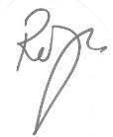

Youth Participation Worker
Milton Keynes Council – Youth:MK

MK Mayor’s Award - Application form
(These headings can be copied into your own Word document)

Project information

Name of your project /or person

What is the aim of your project? /What did the person do?

What would you like to tell us about your project/person?
Please think about why they did it, how they did it, how they overcome problems. How does it connect to democratic and/or citizenship activity that has happened For example, it could be that the club ran a questionnaire about issues and the project came out from that questionnaire or they voted on a charity fundraiser, they renovated a public garden… OR and individual has been litter picking.

What was learnt?

What did members of the community get out of it?
Community can be geographic, school, interest group, whole of MK etc…

When did the project/activity start and when did it finish?

What, if any, supporting information have you submitted?
Please feel free to add any photos, quotes etc.

Essential information

Name of person nominating _______________________________________________________

Relationship to Nominees (friend, youth worker etc) ____________________________________

Name/s of young people nominated
Name | Age | School

Name of Club/Group (if applicable) __________________________________________________

Any other adults/partner organisations involved in the project/activity

______________________________________________________________________________

______________________________________________________________________________

Once winners have been identified we will be in touch to contact them directly. All nominees will receive a certificate to acknowledge their citizenship and democracy work.

I am happy for this to be turned into a positive story (with identities hidden) and shared with the public □
Please check with me before the story is shared □

Data Protection Privacy Statement: Your information will be used by the Community Learning Department and Democratic services at MK Council for the purposes MK Mayor’s Award. We require the above for the purposes of informing the nominator and participant of the results of the competition in turn the educational provider/work too. Winners information will be shared within MK Council for the purpose of the Award and passed on for media purposes. Some of the applications may be used as positive stories with identities/schools etc hidden, and shared with the public. Information not needed or used will be disposed of securely and all applications will be destroyed at the end of the process. We work within MK Councils Data Protection statement which can be found at https://www.milton-keynes.gov.uk/your-council-and-elections/council-information-and-accounts/data-protection-and-confidentiality.

Please be aware that with the current situation that dates/events may change or cancelled.

Signed Nominator (can be type) Date

________________________________ _______________________________

